Homework Takeaway Menu
Reception
Autumn 1
Parent/carer to initial when completed
Recognise your own name.
Count 5 objects, pointing to each one.
Draw a picture of yourself. Don’t forget your eyes, nose and ears.
Listen to a bedtime story and answer questions about what is going on.
Starters

Mains
Parent/carer to initial when completed
Read at least twice a week for 5 minutes at a time.
Practice recognising and writing numbers from 1-5.
Practice writing your own name, forming letters correctly.
Practice letter/sound recognition for all sounds in Set 1 below.
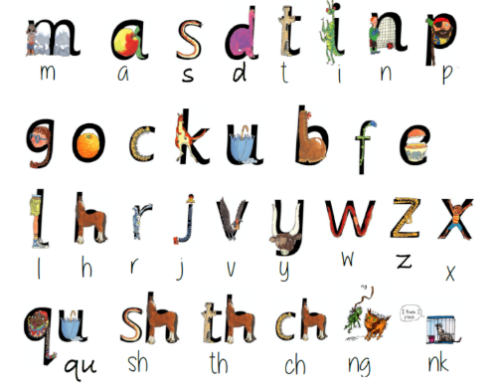

Sides
Parent/carer to initial when completed
Look for numbers in the environment. How many do you recognise? (See picture below). Can you make a poster to show the numbers that you see?
Go for an Autumn walk and collect leaves, sticks, conkers and acorns. Can you make shapes with the sticks? How many conkers can you count? What colour are the leaves?

