Weekly Spellings Week 1: Homophones
These spellings will be tested next Monday. This side gives children the opportunity to practice using the ‘Look, Cover, Write and Check’ strategy, on the reverse, is a different activity to aid the learning of these spellings.
Look | Cover/Write | Cover/Write | Cover/Write | Cover/Write | Cover/Write
Two
Too
To
Their
They’re
There

Write
Right
Peace
Piece

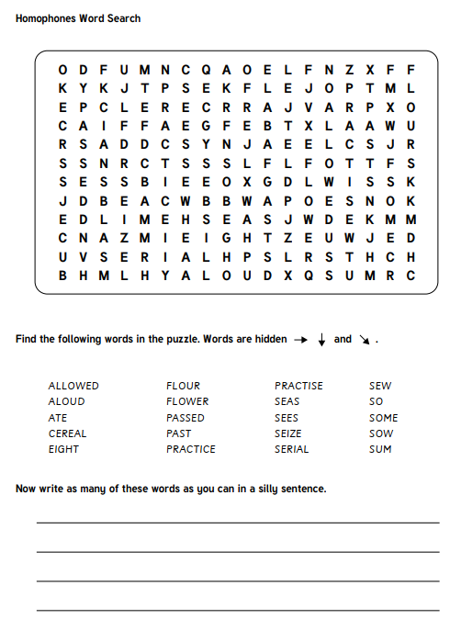

Weekly Spellings Week 2: prefix al-
These spellings will be tested next Monday. This side gives children the opportunity to practice using the ‘Look, Cover, Write and Check’ strategy, on the reverse, is a different activity to aid the learning of these spellings.

Look | Cover/Write | Cover/Write | Cover/Write | Cover/Write | Cover/Write
Also
Although
Almost
Always
Almighty
Already
Alright
Altogether

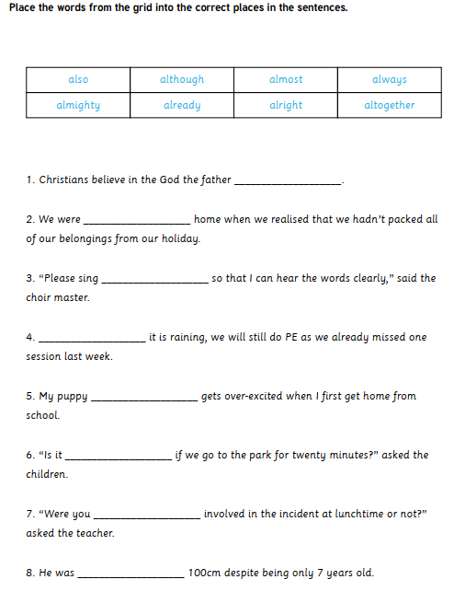

Weekly Spellings Week 3: suffix -ful
These spellings will be tested next Monday. This side gives children the opportunity to practice using the ‘Look, Cover, Write and Check’ strategy, on the reverse, is a different activity to aid the learning of these spellings.
Look | Cover/Write | Cover/Write | Cover/Write | Cover/Write | Cover/Write
Grateful
Faithful
Hopeful
Careful
Helpful
Useful
Grateful
Beautiful
Boastful
Painful

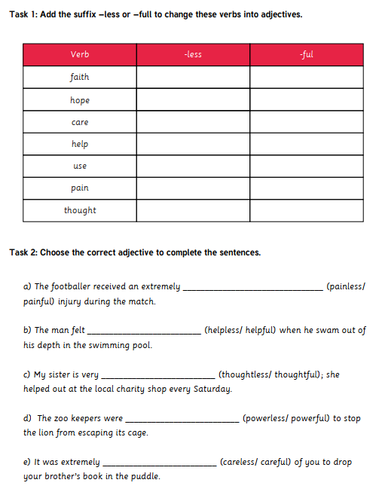

Weekly Spellings Week 4: Comparatives and Superlatives
These spellings will be tested next Monday. This side gives children the opportunity to practice using the ‘Look, Cover, Write and Check’ strategy, on the reverse, is a different activity to aid the learning of these spellings.
Look | Cover/Write | Cover/Write | Cover/Write | Cover/Write | Cover/Write
Beautiful
Happiness
Angrier
Prettier
Readily
Dried
Defied
Applies
Silliness
Heavier

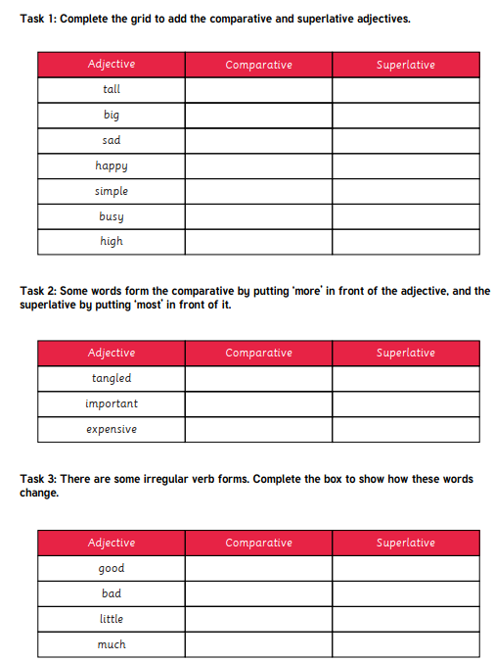

Weekly Spellings Week 5: -ous suffix
These spellings will be tested next Monday. This side gives children the opportunity to practice using the ‘Look, Cover, Write and Check’ strategy, on the reverse, is a different activity to aid the learning of these spellings.
Look | Cover/Write | Cover/Write | Cover/Write | Cover/Write | Cover/Write
Tremendous
Ridiculous
Ravenous
Numerous
Nervous
Miraculous
Joyous
Jealous
Generous
Fabulous

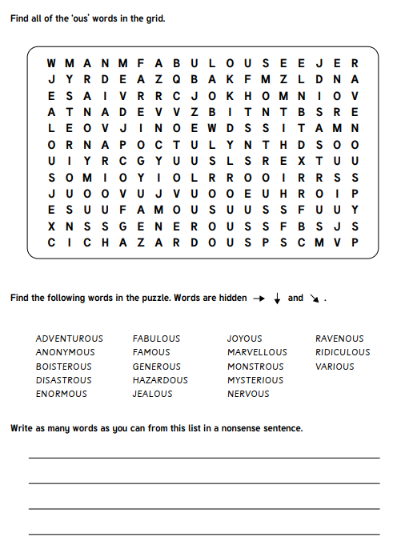

Weekly Spellings Week 6: Revision week
These spellings will be tested next Monday. This side gives children the opportunity to practice using the ‘Look, Cover, Write and Check’ strategy, on the reverse, is a different activity to aid the learning of these spellings.
Look | Cover/Write | Cover/Write | Cover/Write | Cover/Write | Cover/Write

